EECE 210 – Quiz 2

November 12, 2011

4%

1. A circuit has 20 essential branches, 11 essential nodes and 10 meshes. How many independent KCL equations can be written for this circuit?
2. 8
3. 6
4. 7
5. 10
6. 9

**Answer:** The number of independent KCL equations is one less than the number of essential nodes.

**Version 1:** *N* = 11, number independent KCL equations = 10

**Version 2:** *N* = 10, number independent KCL equations = 9

**Version 3:** *N* = 9, number independent KCL equations = 8

**Version 4:** *N* = 8, number independent KCL equations = 7

**Version 5:** *N* = 7, number independent KCL equations = 6.

4%

1. How many independent KVL equations can be written for the circuit of the preceding question?
2. 11
3. 10
4. 9
5. 12
6. 13

**Answer:** The number of independent KVL equations is same as the number of meshes.

**Version 1:** *L* = 10, number independent KVL equations = 10

**Version 2:** *L* = 11, number independent KVL equations = 11

**Version 3:** *L* = 12, number independent KVL equations = 12

**Version 4:** *L* = 13, number independent KVL equations = 13

**Version 5:** *L* = 14, number independent KVL equations = 14.

4%

1. Determine *VO*.
2. 2 V
3. 4 V
4. 0
5. 1.5 V
6. 2.5 V

**Solution:** Since the circuit does not have any independent sources, *VO* = 0. This can also be shown by analyzing the circuit. Thus, 1.25*Vx* = *VO*, so *I*1 = *Vx*/1 = *VO*/1.25 = 0.8*VO*; *I*2 = 0.5*VO*/2 = 0.25*VO*; *IO* = *VO*/5 = 0.2*VO*. Applying KCL, 0.8*VO* + 0.25*VO* + 0.2*VO* = 0, or 1.25*VO* = 0, so *VO* = 0.



4%

1. Given that *Va* = 25 V and *Vb* = 12 V. Determine *Va* if node b is grounded instead of c.
2. 13 V
3. 37 V
4. 14 V
5. 15 V
6. 16 V

**Solution:** When node b is grounded, *Vb* = 0. Hence, 12 V is subtracted from all node voltages, and *Va* = 25 – 12 = 13 V. Alternatively, it can be argued that the voltage drop from a to b is 13 V irrespective of which node is grounded.

**Version 1:** *Vb* = 12, *Va* = 13 V

**Version 2:** *Vb* = 11, *Va* = 14 V

**Version 3:** *Vb* = 10, *Va* = 15 V

**Version 4:** *Vb* = 9, *Va* = 16 V

**Version 5:** *Vb* = 8, *Va* = 17 V.

4%

1. The power dissipated in *R* is 8 W if *ISRC* is applied alone, with *VSRC* set to zero, and is 0.5 W if *VSRC* is applied alone, with *ISRC* set to zero. Determine the power dissipated in *R* if both sources are applied together, with polarities that will give the largest current in *R*.
2. 8.5 W
3. 18 W
4. 24.5 W
5. 32 W
6. 12.5 W

**Solution:** When *ISRC* source is applied alone, with *VSRC* set to zero, the current in *R* is  A. When *VSRC* is applied alone, with *ISRC* set to zero, the current in *R* is . With both sources applied together to to give the largest current in *R*, the total current in *R* is  and the power dissipated in *R* is .

**Version 1:** *PV* =0.5 W, *PT* =8 + 4 + 0.5 = 12.5 W

**Version 2:** *PV* =2 W, *PT* =8 + 8 + 2 = 18 W

**Version 3:** *PV* =4.5 W, *PT* =8 + 12 + 4.5 = 24.5 W

**Version 4:** *PV* =8 W, *PT* =8 + 16 + 8 = 32 W

**Version 5:** *PV* =12.5 W, *PT* =8 + 20 + 12.5 = 40.5 W.

4%

1. Determine Thevenin’s equivalent circuit (TEC) looking into terminals ab, assuming *VSRC* = 5 V and *ISRC* = 2 A.
2. *VTh* = 12 V, *RTh* = 2 Ω
3. *VTh* = 15 V, *RTh* = 6 Ω
4. *VTh* = 12 V, *RTh* = 6 Ω
5. *VTh* = 15 V, *RTh* = 2 Ω
6. TEC does not exist

**Solution:** On open circuit, *ISCR* flows through the 6 Ω resistor, so that *VTh* = 6*ISRC*. If a test source is applied with the voltage source replaced by short circuit and the current source replaced by an open circuit, the resistance looking into terminals ab is *RTh* = 6 Ω.

**Version 1:** *ISRC* = 2 A, *VTh* = 6*ISRC* = 12 V; *RTh* = 6 Ω

**Version 2:** *ISRC* = 2.5 A, *VTh* = 6*ISRC* = 15 V; *RTh* = 6 Ω

**Version 3:** *ISRC* = 3 A, *VTh* = 6*ISRC* = 18 V; *RTh* = 6 Ω

**Version 4:** *ISRC* = 3.5 A, *VTh* = 6*ISRC* = 21 V; *RTh* = 6 Ω

**Version 5:** *ISRC* = 4 A, *VTh* = 6*ISRC* = 24 V; *RTh* = 6 Ω.

4%

1. Determine Norton’s equivalent circuit (NEC) looking into terminals ab, assuming *VSRC* = 5 V and *ISRC* = 2 A.
2. *IN* = 2 A, *RN* = 5 Ω
3. NEC does not exist
4. *IN* = 3 A, *RN* = 5 Ω
5. *IN* = 4 A, *RN* = 5 Ω
6. *IN* = 2 A, *RN* = 0

**Solution:** On open circuit, *VTh* = *VSRC*. If *VSRC* and *ISRC* are set to zero, the resistance looking into terminals ab is that of a short circuit, so *RTh* = 0. If terminals ab are short-circuited, *IN* → ∞. Hence, TEC is the ideal voltage source *VSRC*, and NEC does not exist.

4%

1. Determine TEC looking into terminals ab, assuming *VSRC* = 4 V.
2. *VTh* = 4 V, *RTh* = 75 Ω
3. *VTh* = 4 V, *RTh* = 300 Ω
4. *VTh* = 4 V, *RTh* = 100 Ω
5. *VTh* = 3 V, *RTh* = 300 Ω
6. *VTh* = 3 V, *RTh* = 75 Ω

**Solution:** The 1 kΩ resistor and the dependent current source are redundant because they are in parallel with an ideal voltage source. The circuit reduces to a voltage source connected to a 100 Ω-300 Ω voltage divider with terminals ab across the 300Ω resistor. It follows that *VTh* = *VSRC*×300/400 = 3*VSRC*/4. If a test source is applied with *VSRC* replaced by a short circuit, the resistance looking into terminals ab is *RTh* = 100||300 = 75 Ω.

Alternatively, if *Ix* is the current flowing in the 100 Ω resistor toward node a, with the output open circuited, then *Vφ* = *VSRC* – 100*Ix* and *Vφ* = 300*Ix*. Eliminating Ix gives *VTh* = *Vφ* = 3*VSRC*/4.

**Version 1:** *VSRC* = 4 V, *VTh* = 3*VSRC*/4 = 3 V, *RTh* = 75 Ω

**Version 2:** *VSRC* = 8 V, *VTh* = 3*VSRC*/4 = 6 V, *RTh* = 75 Ω

**Version 3:** *VSRC* = 12 V, *VTh* = 3*VSRC*/4 = 9 V, *RTh* = 75 Ω

**Version 4:** *VSRC* = 16 V, *VTh* = 3*VSRC*/4 = 12 V, *RTh* = 75 Ω

**Version 5:** *VSRC* = 20 V, *VTh* = 3*VSRC*/4 = 15 V, *RTh* = 75 Ω

4%

1. Determine, according to the substitution theorem, which of the following ideal circuit elements can replace the dependent source without affecting the currents and voltages in the rest of the circuit (Mark all correct answers if you believe that more than one answer is correct).
2. Independent 4 V source
3. Dependent 4 V source
4. Dependent 2 A source
5. Independent 2 A source
6. 2 Ω resistor

**Solution:** From KCL at node a, 3 = 3*Ix*, so *Ix* = 1 A, and *Vab* = 4 V. The voltage across the dependent source is 4 V and the current through this source is 2 A. According to the substitution theorem, the dependent source can be replaced by: i) an independent 4 V source, ii) an independent 2 A source, or iii) a 2 Ω resistor. Replacing the dependent source by any of these elements does not affect the voltages and currents in the rest of the circuit, as indicated by the figures shown.



4%

1. All resistances are 1 Ω, except for the two 4 Ω resistances indicated. Determine the source current, assuming *VSRC* = 1 V.
2. 2 A
3. 5 A
4. 3 A
5. 1 A
6. 4 A

**Solution:** Consider the two half circuits shown, If nodes a and a′ are at the same voltage, say 0 V, then from symmetry, nodes b and b′, c and c′, and d and d′ will be at the same voltage. Hence, nodes b and b′, and c and c′, can be connected directly together, and nodes a and a′ and d and d′ can be connected through resistances of any value, say 1 Ω, without disturbing the circuits. If this is done, the original circuit is obtained. In each half circuit, the resistance in parallel with the source is 3||6 = 2 Ω, and the resistance in parallel with *VSRC* in the original circuit is 2||2 = 1 Ω. The source current is therefore *VSCR* A.

**Version 1:** *VSRC* =1 V, *ISRC* =1 A

**Version 2:** *VSRC* =2 V, *ISRC* =2 A

**Version 3:** *VSRC* =3 V, *ISRC* =3 A

**Version 4:** *VSRC* =4 V, *ISRC* =4 A

**Version 5:** *VSRC* =5 V, *ISRC* =5 A.

20%

**11.** Determine *IO* assuming all resistances are 1 Ω and *VSRC* = 5 V.

**Solution:** Superposition can be applied. If the 10 V source is applied alone, with *VSRC* replaced by a short circuit, the component of *IO* is zero. If *VSRC* is applied alone, *IO* is determined by *VSRC* and what happens in the circuit to the left of *VSRC* is not relevant to *IO*. The resistor across *VSRC* is redundant, and the circuit reduces to that shown. If scaling is applied, assuming *IO* = 1 A, then *Vcd* = 3 V, *Iac* = *Ibd* = 4A, *Vab* = 2×4×1 + 3 =11 V, *ISRC* = 15 A, and *VSRC* = 2×15×1 + 11 = 41 V. Hence, *IO* = *VSRC*×(1/41). Alternatively, *VSRC* can be divided into two sources, and the left-hand part of the circuit reduces to that shown.

**Version 1:** *VSRC =* 5 V, *IO* = *VSRC*/41 = 0.12 A

**Version 2:** *VSRC =* 7.5 V, *IO* = *VSRC*/41 = 0.18 A

**Version 3:** *VSRC =* 10 V, *IO* = *VSRC*/41 = 0.24 A

**Version 4:** *VSRC =* 12.5 V, *IO* = *VSRC*/41 = 0.30 A

**Version 5:** *VSRC =* 15 V, *IO* = *VSRC*/41 = 0.37 A.

20%

**12.** Determine *IO* assuming *VSRC* = 5 V.

**Solution.** *Method 1* (KCL and KVL): The current in the 2 Ω resistor is *IO*, by KVL. The currents in the upper 1 Ω resistors will be as shown. Applying KVL to the upper mesh: *VSRC* = 3*IO*×1 + *IO*×2 = 5*IO*. This gives *IO* = *VSRC*/5.

*Method 2* (Superposition): 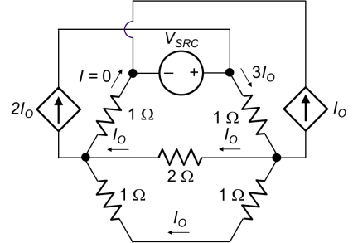Superposition can be applied with the 2*IO* dependent source replaced by an independent source of value *Ix*, and the *IO* dependent source replaced by an independent source of value *Iy.*When *VSRC* is applied alone, with the current sources replaced by an open circuit, the circuit becomes as shown. The source current is *VSRC*/3 A, and *IO*1 = *VSRC*/6 A. When *Ix* is applied alone, with the other sources set to zero, the circuit becomes as shown. It follows that *IO*2 = *Ix*/6 A. When *Iy* is applied alone, with the other sources set to

zero, the circuit becomes as shown. It follows that *IO*3 = -*Iy*/6 A. Hence, *IO* = *VSRC*/6 + *Ix*/6 – *Iy*/6. Substituting *Ix* = 2*IO* and *Iy* = *IO*, *IO* = *VSRC*/6 + *IO*/6, which gives *IO* = *VSRC*/5.

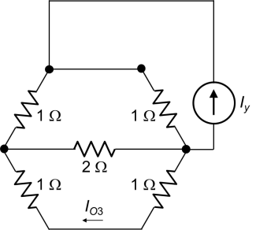

*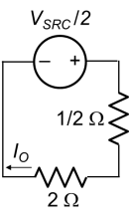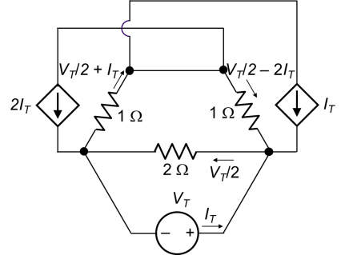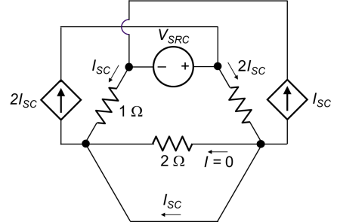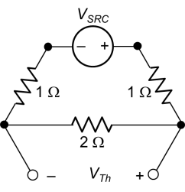Method 3* (TEC): If the branch through which IO flows is open-circuited, then *IO* = 0 and the two current sources become open circuits. From voltage division, *VTh* = *VSRC*/2. If this branch is short-circuited, the circuit becomes as shown. From KVL in the upper mesh, *VSRC* = 2*ISC*×1 – *ISC*×1, = *ISC*, so that *RTh* = *VTh*/*ISC* = 1/2 Ω. Alternatively, if a test source is applied, the circuit becomes as shown. From KVL in the upper mesh, (*VT*/2 – 2*IT*)×1 + (*VT*/2)×2 + (*VT*/2 + *IT*)×1 = 0, which gives 2*VT* = *IT*, so *RTh* = *VT*/*IT* = 1/2 Ω as before. In terms of TEC the circuit becomes as shown. It follows that IO = (*VSRC*/2)/2.5 = *VSRC*/5.

**Version 1:** *VSRC =* 5 V, *IO* = *VSRC*/5 = 1 A

**Version 2:** *VSRC =* 7.5 V, *IO* = *VSRC*/5 = 1.5 A

**Version 3:** *VSRC =* 10 V, *IO* = *VSRC*/5 = 2 A

**Version 4:** *VSRC =* 12.5 V, *IO* = *VSRC*/5 = 2.5 A

**Version 5:** *VSRC =* 15 V, *IO* = *VSRC*/5 = 3 A

20%

**13.** Write five independent circuit equations based on the node-voltage method, assuming all resistances are 2 Ω. The only unknowns in these equations should be *Va*, *Vb*, *Vc*, *Vd*, and *Ve*, in this order. **DO NOT SOLVE THESE EQUATIONS**. (4 grades are assigned to each required equation).

**Solution:** The resistor in series with the 5 A source is redundant and could be removed without affecting the

rest of the circuit. The dependent voltage source is equivalent to a resistance of 0.5*Iy*/*Iy* = 0.5 Ω, which in series with the 2 Ω resistance becomes 2.5 Ω, or 0.4 S. The circuit becomes as shown, where the two grounded nodes are the same node. One circuit equation is: *-Vc* + *Ve* = 10. The node-voltage equation for node a is: (0.5 + 0.5 + 0.5)*Va* – 0.5*Vc* = 0, or 3*Va* – *Vc* = 0. The node-voltage equation for node b is: (0.5 + 0.5)*Vb* – 0.5*Vc* = -5, or 2*Vb* – *Vc* = -10. The node-voltage equation for node c is: -0.5*Va* – 0.5*Vb* + (0.5 + 0.5 + 0.5)*Vc* – 0.5*Vd* = *Ix*, or

-0.5*Va* – 0.5*Vb* + 1.5*Vc* – 0.5*Vd* = *Ix*. The node-voltage equation for node d is: -0.5*Vc* + 0.9*Vd* – 0.4*Ve* = 0.5*Ix*.The node-voltage equation for node e is: -0.4*Vd* + 0.4*Ve* = 5 – *Ix*. Adding the equations for nodes c and e to eliminate *Ix* gives: -0.5*Va* – 0.5*Vb* + 1.5*Vc* – 0.9*Vd* + 0.4*Ve* = 5, or, -5*Va* – 5*Vb* + 15*Vc* – 9*Vd* + 4*Ve* = 50. Multiplying the node-voltage equation for node d by 2 and adding to the node voltage equation for node e to eliminate *Ix*: -*Vc* + 1.4*Vd* – 0.4*Ve* = 5, or -5*Vc* + 7*Vd* – 2*Ve* = 25.